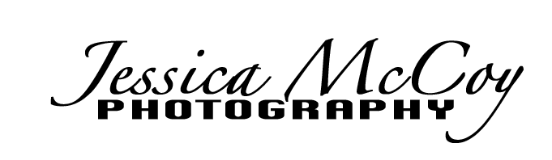
Copyright Release Form for Photography

To:_________________________________
From: Jessica McCoy, Jessica McCoy Photography
Re: Pictures take on _______________________

By receipt of this letter, I, Jessica McCoy, owner of Jessica McCoy Photography, grant permission to above named to reproduce the photos taken on above date. They can reproduce as many times and at any size they wish for their own personal use. Not for commercial use (website, newspaper, magazine, flyers , etc.)
Any infringement may violate federal law.

Signed:_________________________________________(photographer)
Date: _________________________

